# Practical No: 05

**Aim:** Configuring Auto Profiles ACU Utilities

**Components:** WLC (Wireless LAN Controller), AP (Access point), Switch, Server, Laptop, Smartphone, Tablet

**Theory:** A network access control list (ACL) is made up of rules that either allow access to a computer environment or deny it. In a way, an ACL is like a guest list at an exclusive club. Only those on the list are allowed in the doors. This enables administrators to ensure that, unless the proper credentials are presented by the device, it cannot gain access.

**Cisco Packet Tracer Setup: - Implementation:**

**Step 1:** Arranging devices and creating connections

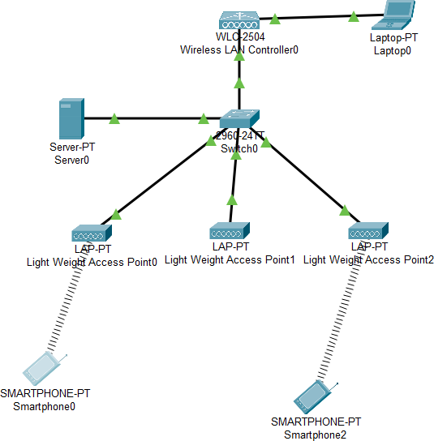

**Step 2:** WLC (Wireless LAN Controller): Config > Management

IPv4 address: 10.10.10.5 Default Gateway: 10.10.10.1

DNS Server: 10.10.10.2

**Step 3:** Configuring Laptop and server and checking connection: In Laptop IP Config,

IPv4 address: 10.10.10.10 Default Gateway: 10.10.10.1

DNS Server: 10.10.10.2

In Server0 Config > Fastethernet0,

IPv4 address: 10.10.10.3 Port Status: On In Server0 > Services > DHCP

Interface: (FastEthernet) Service: ON

Default Gateway: 10.10.10.1 DNS Server: 10.10.10.2 Start IP Address: 10.10.10.100 Subnet Mask: 255.0.0.0 Max no. of users: 100

Click on ‘Add’ and then ‘Save’

Check the connection from laptop0 command prompt with C:\> ping 10.10.10.1

**Step 4:** Configuring Admin settings using address ([http://10.10.10.5](http://10.10.10.5/)) in the web browser of Laptop2:

* 1. Create a new username and password and remember it for further steps
  2. In the next page, (Set up your Controller)

System Name: GJCCS Management IP Address: 10.10.10.5 Subnet Mask: 255.0.0.0 Default Gateway: 10.10.10.1 Management VLAN ID: 0

* 1. In the Create your Wireless Networks,

Network name: STUDENT Security: WPA2 Personal

Passphrase: student

* 1. Click Next in the Advanced Setting section and Apply in the final section

**Step 5:** Login back to Admin Panel using address ([https://10.10.10.5](https://10.10.10.5/)) with the new Admin name and password:

Make sure the 3 Access points are present in the Wireless section,

If not, then re-plug all the access points in the physical section and hit refresh on the top right of the web browser of Laptop0

Go to WLAN make SSID for STUDENT to Student

**Step 6:** Add new wireless LAN as TEACHER with SSID Teacher and apply and make sure the status is enabled:

**Step 7:** Create AP Groups for TEACHER and STUDENT:

1. In the WLAN tab, select AP Group on the left of the page, below the Advanced section
2. Inside, enter

AP Group Name: STUDENT Description: Student AP And click ‘add’

1. In the WLAN section, select WLAN SSID as Student and add
2. Go to the APs section and select the first 2 access points and add them to this AP Group
3. Now Repeat above the steps for the TEACHER AP Group and in the access point selection, add the one access point that was left out

**Step 8:** Take Smartphone to connect Student AP group with wireless connection using SSID

**Step 9:** Take another smartphone to connect Teachers AP group with wireless connection using SSID

*Wait for some time (min 30sec to 1min) after that re-plug the adapters of all Access points*

**Step 10:** Send packets from one smartphone to the other

**Output:**

